HELLO AND GOOD-BYE
Your Vocabulary Log
Make a vocabulary log. Write words or draw pictures to help you remember.

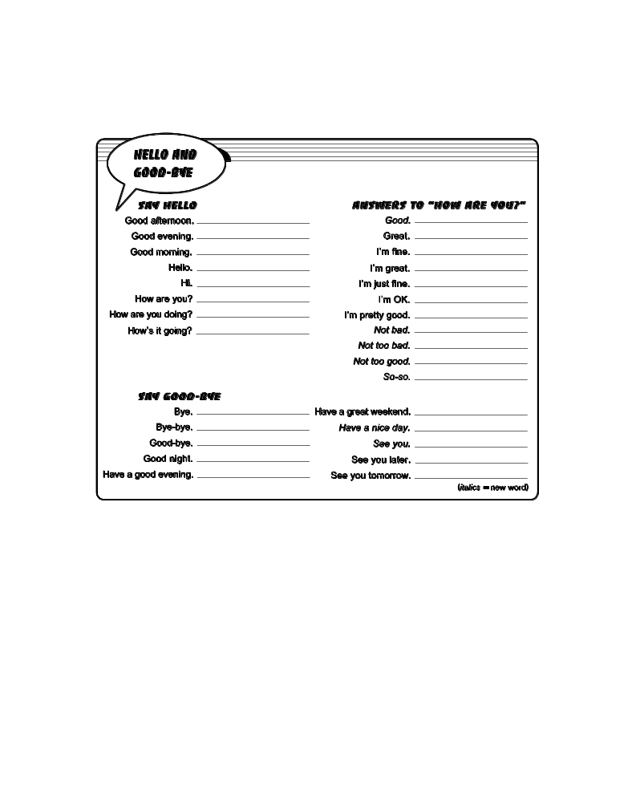
Practice
PAIR WORK Say hello and good-bye in different ways.
Use words or expressions from your vocabulary log.
A: Hi, John. How are you?
B: Hello, Michael. I’m pretty good, thanks. How about you?
A: I’m OK, thanks.
Later . . .
A: Bye-bye.
B: See you.

